**RESULTS**

Four genera of ixodic ticks were identified genera (*Amblyomma, Boophilus, Rhipicephalus and Haemaphysalis)*, consisting of twelve (15) species of ticks as shown in Table _. *B. annulatus, B. decoloratus and B. geigyi were the most abundant ticks in the cattles sampled, with overall prevalence of* 42.38%, 29.38% and 20.93%, respectively. These three species of ticks made up over 92% of ticks collected from all tick-positive cattle. Also, rare species were observed, such as

*R. quilhoni, H. laechi and and unidentified* species in the *Boophilus* Genus.

Based on sex, Females made up most of the ticks sampled.

Table 2: Tick species prevalence (%)

|  |  |  |  |  |  |  |  |
| --- | --- | --- | --- | --- | --- | --- | --- |
| **Species** | **Belly** | **Head** | **Leg** | **Neck** | **Shoulder** | **Tail** | **Total** |
| ***A. coharenses*** | 0.23 | 0.56 | 0.48 | 0.71 | 0 | 0.58 | 0.47 |
| ***A. variegatum*** | 1.62 | 1.69 | 3.6 | 1.42 | 0 | 4.36 | 2.44 |
| ***B. annulatus*** | 49.31 | 37.36 | 41.97 | 41.84 | 21.21 | 45.93 | 42.38 |
| ***B. decoloratus*** | 30.32 | 28.09 | 33.57 | 25.89 | 44.44 | 22.97 | 29.38 |
| ***B. geigyi*** | 17.36 | 20.79 | 19.18 | 27.3 | 28.28 | 20.35 | 20.93 |
| ***Boophilus sp.*** | 0 | 0 | 0 | 0 | 0 | 0.87 | 0.16 |
| ***H. laechi*** | 0 | 0.28 | 0 | 0 | 0 | 0.58 | 0.16 |
| ***R. gulhoni*** | 0 | 3.09 | 0 | 1.06 | 2.02 | 0.87 | 0.98 |
| ***R. lunulatus*** | 0.46 | 2.53 | 0.96 | 0 | 4.04 | 2.03 | 1.35 |
| ***R. muhsame*** | 0.23 | 1.4 | 0.24 | 0.35 | 0 | 0.58 | 0.52 |
| ***R. quilhoni*** | 0 | 0.28 | 0 | 0 | 0 | 0.29 | 0.1 |
| ***R. sanguineus*** | 0 | 3.09 | 0 | 1.06 | 0 | 0 | 0.73 |
| ***R. senegalensis*** | 0.23 | 0.56 | 0 | 0.35 | 0 | 0.58 | 0.31 |
| ***R. fanguineus*** | 0.23 | 0 | 0 | 0 | 0 | 0 | 0.05 |
| ***R. gemma*** | 0 | 0.28 | 0 | 0 | 0 | 0 | 0.05 |

**Tick community composition at the predilection areas**

The tick community structure of ticks at the predilection sites is represented in the NMDS plot (Figure_). Visually, the plot shows that the six predilection areas have a high overlap in composition and level of dispersion of the ticks. In alliance with the NMDS plot, the PERMANOVA test revealed no significant difference (P> 0.05) in the overall community structure of ticks at the predilection areas. Nonetheless, notable non-significant differences are obvious between the ticks at the cattle Shoulders and some other predilection areas, such as the Belly, Tail, Neck, and Head, as shown in Table 3. Furthermore, the test for homogeneity of dispersion showed no significant difference (P> 0.05) amongst the predilection sites.

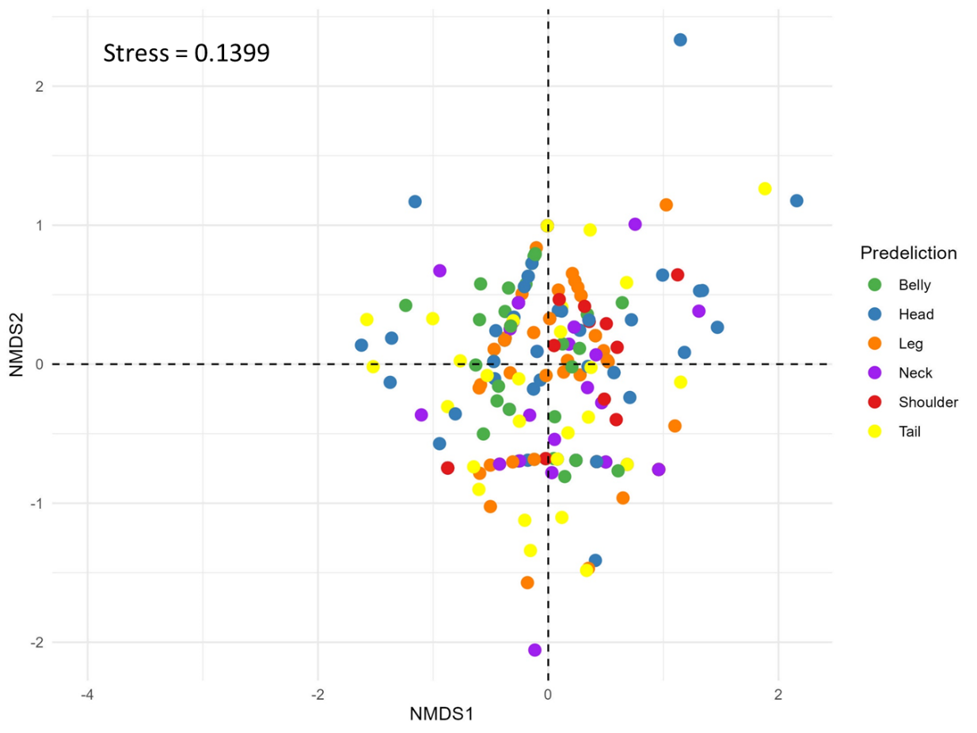

Figure 1: non-metric multidimensional scale (NMDS) plot showing points representing the tick community in predilection sites. Points are coloured according to predilection sites.

Table 3: PERMANOVA comparing the community structure of ticks at the predilection sites.

|  |  |  |  |  |
| --- | --- | --- | --- | --- |
| **pairs** | F-Model | R2 | P-value | Adjusted P-value |
| **Belly vs Head** | 1.899 | 0.016 | 0.082 | 1 |
| **Belly vs Leg** | 0.711 | 0.005 | 0.553 | 1 |
| **Belly vs Tail** | 0.329 | 0.003 | 0.832 | 1 |
| **Belly vs Neck** | 0.686 | 0.006 | 0.592 | 1 |
| **Belly vs Shoulder** | 3.321 | 0.039 | 0.011 | 0.165 |
| **Head vs Leg** | 0.774 | 0.006 | 0.547 | 1 |
| **Head vs Tail** | 0.941 | 0.008 | 0.442 | 1 |
| **Head vs Neck** | 0.936 | 0.009 | 0.427 | 1 |
| **Head vs Shoulder** | 1.054 | 0.013 | 0.404 | 1 |
| **Leg vs Tail** | 0.700 | 0.006 | 0.592 | 1 |
| **Leg vs Neck** | 0.741 | 0.006 | 0.544 | 1 |
| **Leg vs Shoulder** | 0.955 | 0.011 | 0.424 | 1 |
| **Tail vs Neck** | 0.414 | 0.004 | 0.817 | 1 |
| **Tail vs Shoulder** | 2.536 | 0.034 | 0.035 | 0.525 |
| **Neck vs Shoulder** | 2.249 | 0.032 | 0.072 | 1 |

**Male and Female Tick community composition.**

Based on Sex, the tick community structure of ticks is represented in the NMDS plot (Figure_). Visually, the plot shows that the male ticks has higher dispersion and heterogeneity compared to the female ticks which looked relatively homogenous. the PERMANOVA test revealed a significant difference (P< 0.001) in the community structure of males and ticks. Furthermore, the test for homogeneity of dispersion showed significant differences (P< 0.001) amongst both sexes.

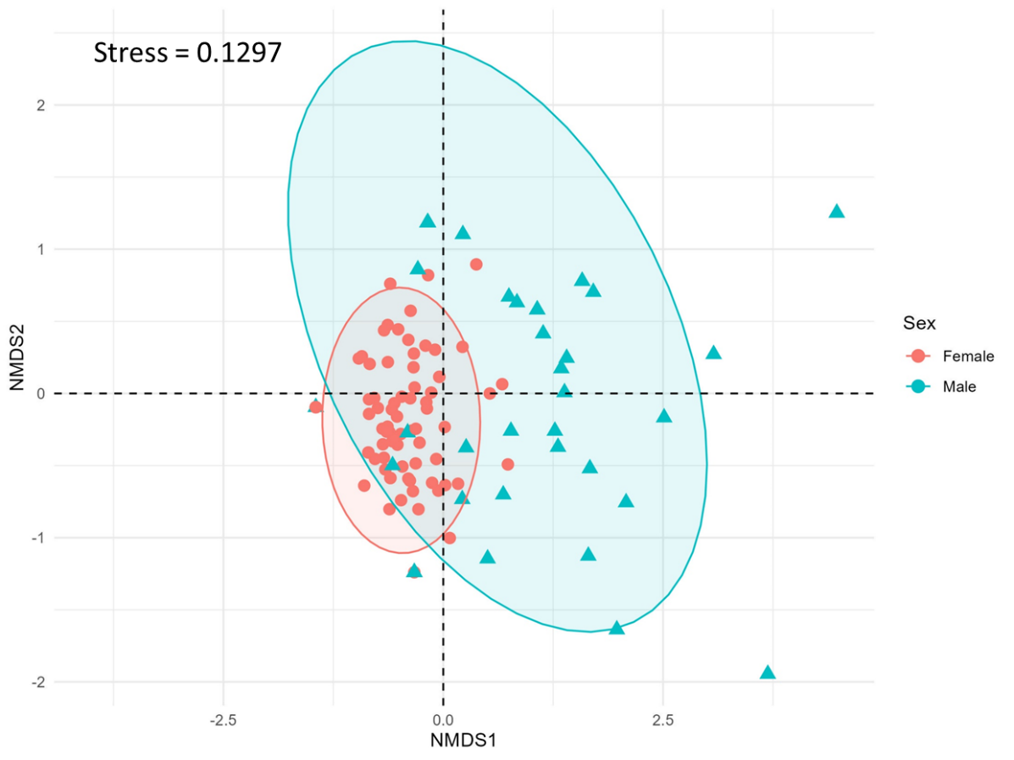

Figure 1: non-metric multidimensional scale (NMDS) plot showing points representing the tick community in predilection sites. Points are coloured according to predilection sites.

**Tick stage and community composition.**

Two tick stages were identified: nymph and adult. There were more cattle with adult ticks () than nymphal staged ticks (). The NMDS plot in Figure _ shows the community structure of both tick stages. However, the NMDS of both communities shows non-significant dissimilarity (p>0.05) in terms of its homogeneity of dispersion. PERMANOVA test shows a significant difference (p<0.001) in the community composition of both tick stages.

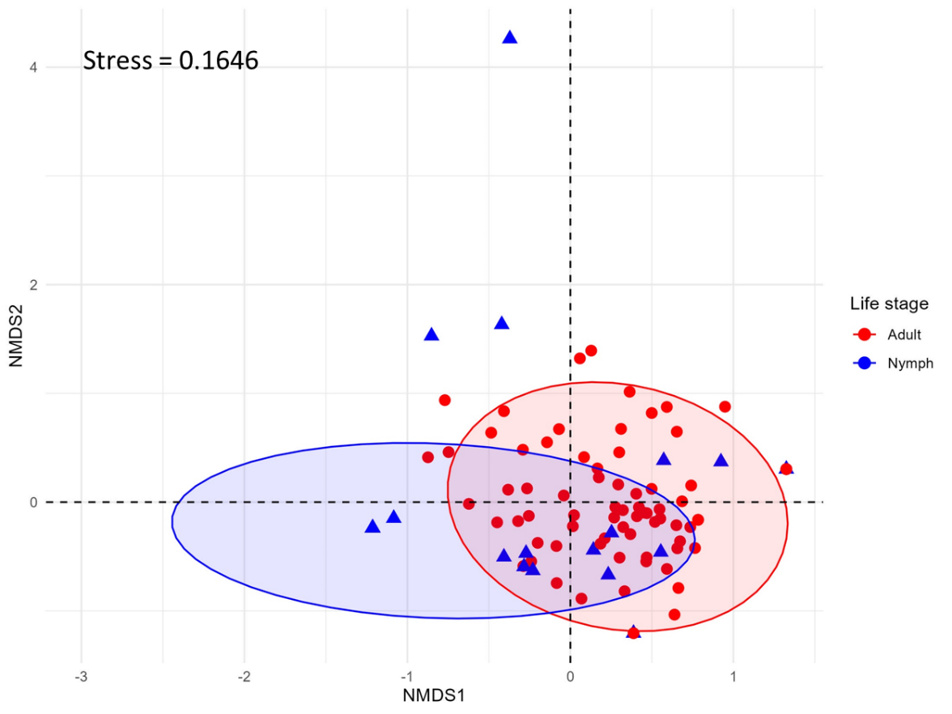

Figure 1: non-metric multidimensional scale (NMDS) plot showing points representing the tick community in predilection sites. Points are coloured according to predilection sites.

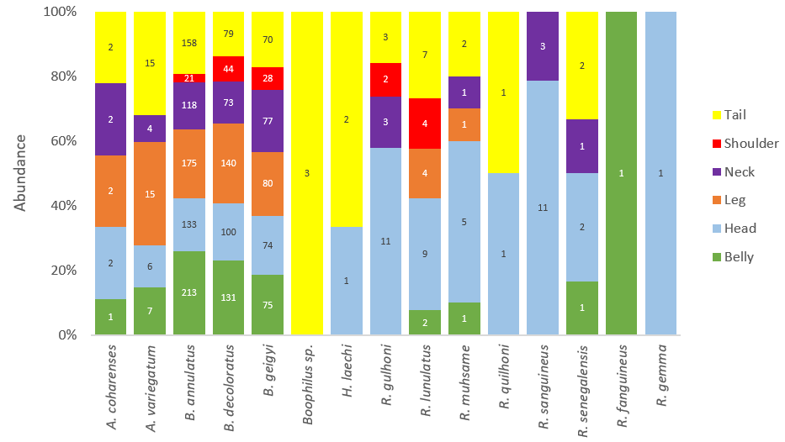

**Figure 4**: Relative abundance (%) of tick species at each predilection site of cattle.

*B. annulatus, B. decoloratus*, and *B. geigyi* were present at all predilection sites at different levels. Also, *A. coharenses* and *A. variegatum* were observed in all predilection areas except shoulders. All *R. gemma*, *R. fonguineus* and *Boophilus* sp. were found in just one predilection site each – Head, Belly and Tail, respectively. *H. laechi* and *R. sanguineus* were present only in the head and tail of the cattle.

**Species richness of ticks**

The observed number of tick species was 15. Figure 5 is a species accumulation curve that estimates the species richness of ticks sampled at the cattle ranch. The SAC shows a mildly upward trend, which suggests that more sampling would have revealed new tick species. The Jackknife 2 and Chao 2 species richness estimates also support this trend. Chao 2 estimates a tick species richness of 16 species, while Jackknife 2 predicts that 19 species are in the area. 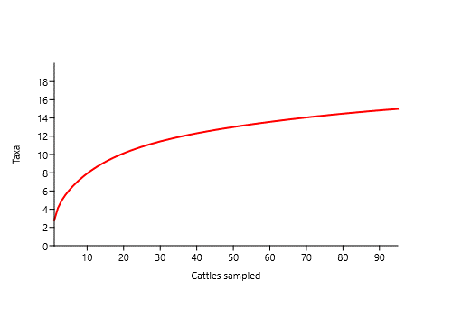

Figure 5: Species accumulation curve (SAC) of ticks sampled

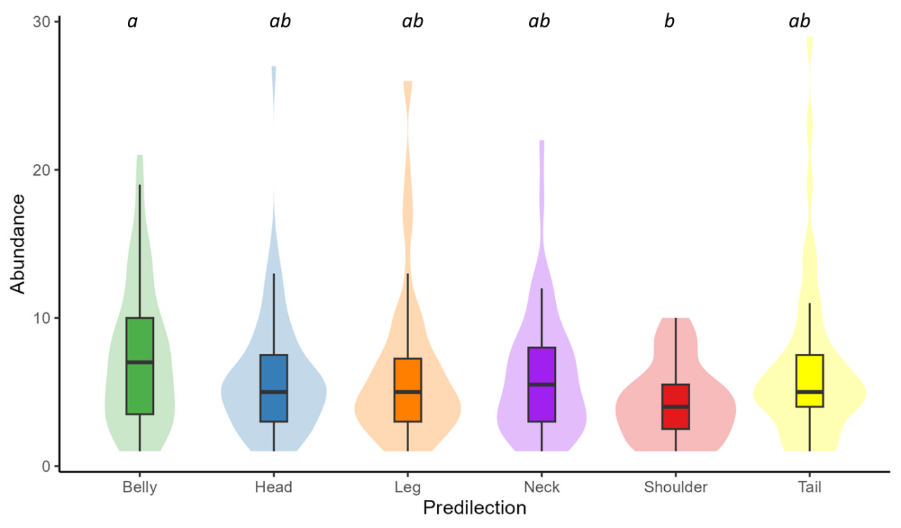

Figure_: Abundance of ticks at the predilection areas in cattle sampled. different letters show significant difference between predilections.

The tick species abundance is represented in the figure_. The tick community in the belly had the belly had the highest mean abundance (7.32±0.62), followed by the tail, leg, neck and head, which had mean abundance of 5.49+0.77, 6.51+0.68, 6.13+0.64 and 6.03+0.55. Particularly, Shoulder had the lowest number of ticks with mean abundance of 4.30+0.55. Negative binomial model showed that the abundance of ticks at the shoulders were significantly (P<0.05) lower than those in the belly.

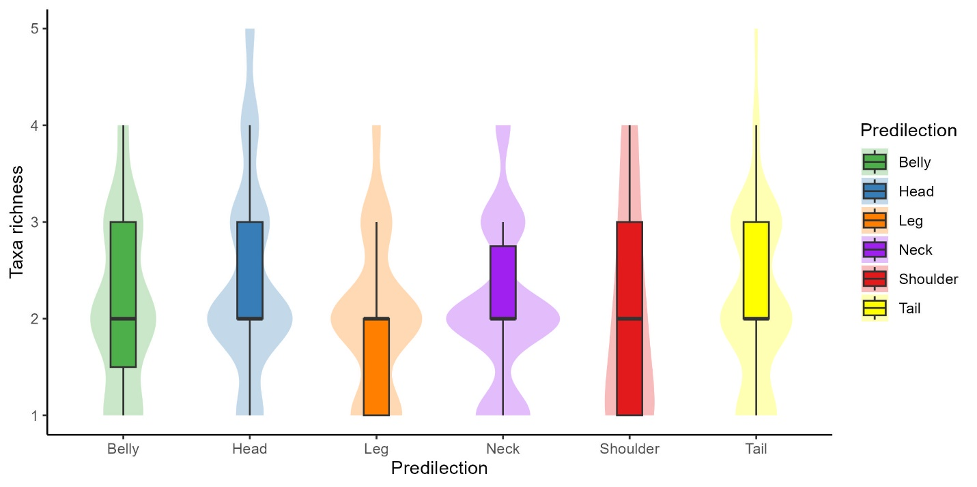

Figure_: Species richness of ticks at the predilection areas in cattle sampled.

Multiple species of ticks were found in most predilection sites, as shown in Figure_. The median species richness was 2 across all predilection sites. However, non-significant variation in tick richness persisted. For example, the cattle’s head had mean tick-species richness of 2.42+0.55, followed by tail, belly and neck which had richness of 2.19+0.77, 2.13+0.62 and 2.09+0.64, respectively. Furthermore, the mean species richest was lowest in the leg (1.98+0.68).

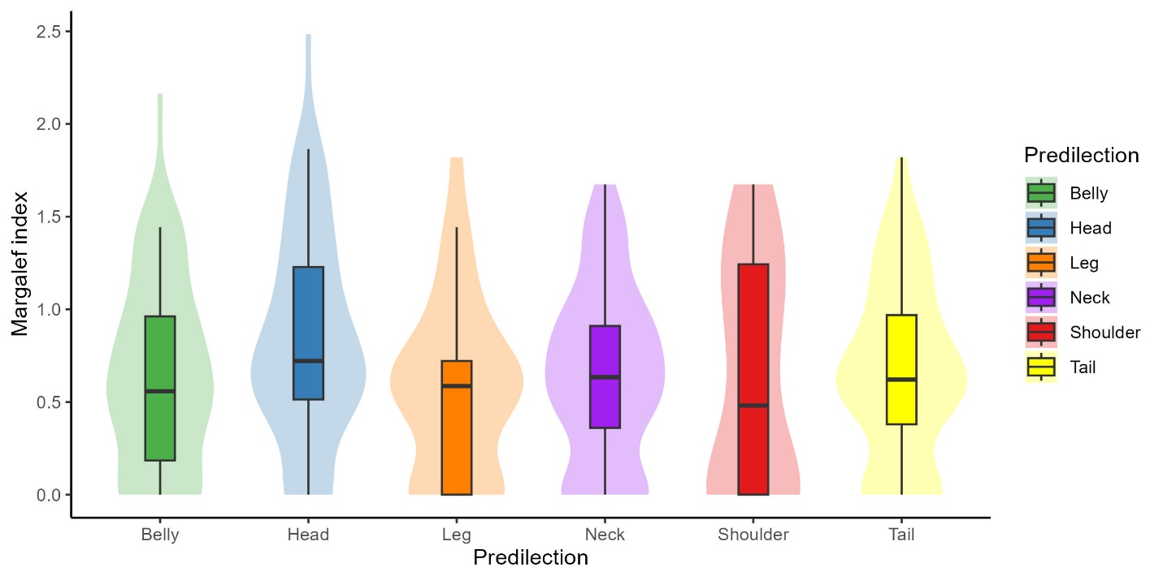

Figure_: Margalef index of ticks at the predilection areas in cattle sampled.

Margalef diversity estimates of ticks at the predilection sites are shown in Figure_. While this index statistically did not vary significantly (P>0.05), slight differences were observed. The Tick head had the highest mean Margalef index (0.83+0.07), followed by the tail (0.65+0.07), neck (0.64+0.07), belly (0.63+0.07) and shoulder (0.62+0.13). The legs had the lowest Margalef index (0.57+0.06) amongst all predilection sites.

The FAMD explains 46.5% of the variance in the tick data using the two dimensions only, with the first and second explaining 23.96% and 22.53%, respectively. The FAMD has revealed notable differences in the qualitative variables (Tick life stages, Predilection area and Sex) of the ticks. The FAMD plot shows that the ticks community show no notable dissimilarity in their preference for certain predilection area. However, the adult and Nymph stages of ticks would contain different tick species compositions as shown in their high disparity on the FAMD plot. The neck, belly and leg of the cattle are qualitatively more similar. Overall, the Nymph had greater affinity for the shoulder and least for the head.

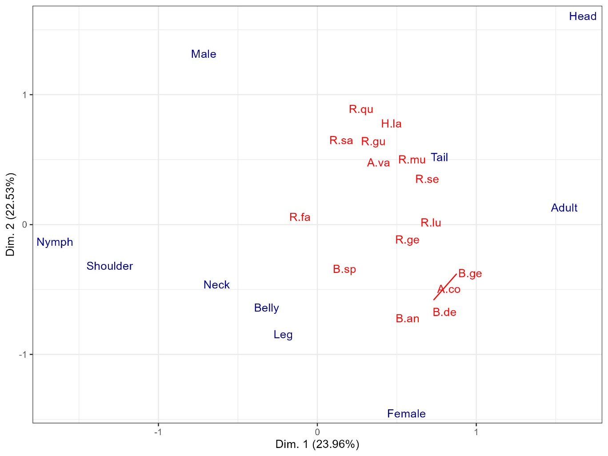

***Figure _: Factorial design of predilection site, life stage and species of ticks in the cattle ranch. A.va, A. variegatum; A.co, A. coharenses; B.an, B. annulatus; B.de, B. decoloratus; B. ge, B. geigyi; H.la, H. laechi; R.gu, R. gulhoni; R.lu, R. lunulatus; R.mu, R. muhsame; R.sa, R. sanguineus; R.se, R. senegalensis; B.sp, Boophilus species; R.qu, R. quilhoni; R.ge, R. gemma; R.fa, R. fanguineus.***